ABSTRACT Computational text analysis has become an exciting research field with many applications in communication research. It can be a difficult method to apply, however, because it requires knowledge of various techniques, and the software required to perform most of these techniques is not readily available in common statistical software packages. In this teacher’s corner, we address these barriers by providing an overview of general steps and operations in a computational text analysis project, and demonstrate how each step can be performed using the R statistical software. As a popular open-source platform, R has an extensive user community that develops and maintains a wide range of text analysis packages. We show that these packages make it easy to perform advanced text analytics.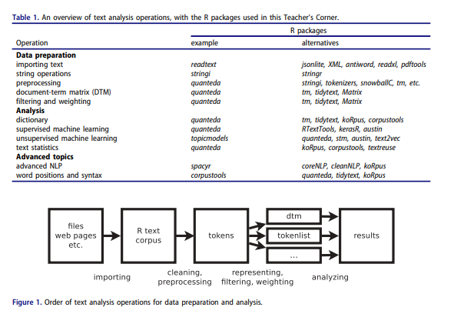

The Key Text Mining Techniques in Use Today
These are processes that are related to mining of text and discovering and understanding of the insights related to it. Text mining techniques generally make use of a multitude of different text mining tools and applications with the aim of perfect execution. Listed below are a bunch of famous text mining techniques that we see in use:

1. Extraction of Information
Information extraction is the most famous text mining technique in practice. This technique involves extraction of insightful information from massive chunks of textual data. The information extraction technique focuses a lot on identifying the extraction of attributes, entities, along with their relationship with unstructured or semi-structured texts. The information extracted is then stored for further analysis or use in a separate database. Precision and recall processes are used to check the efficacy and relevancy of outcomes.

2. Retrieval of Information
The retrieval of information technique is the process where extraction of relevant and associated patterns is extracted based on a particular set of phrases or words. This technique makes use of information retrieval systems that make use of various algorithms that track and monitor user behaviour and also determine related data accordingly. The biggest and most famous Information Retrieval system that all of us are aware of is Google!

3. Categorization
Categorization is a text mining technique which is a ‘supervised’ learning form where the usual language texts are set to a pre-defined bunch of topics depending on their content. Therefore, categorization or NLP (Natural Language Processing) is the process of gathering text documents for processing and analysis with the aim of uncovering the indexes or right topics for the relevant document. As a part of NLP, the co-referencing method is usually used. It is used to extract abbreviations and relevant synonyms from text data. The use cases of NLP in text analytics have increased tremendously today and range from spam filtering to personalized commercial delivery to webpage categorization under tiered definitions.

4. Clustering
An important text mining technique is Clustering. Clustering helps identify structures that are intrinsic in nature within text information and organize them in clusters or relevant subgroups for further analysis. Forming meaningful clusters from unlabelled text data without prior information about them is one key challenge faced while performing clustering. Cluster analysis is a text analytics tool that assists with distribution of data or becomes a pre-processing stage for text mining algorithms which run on detected clusters.

5. Summarization
Multiple industries today such as academia, healthcare, law, finance and many more are being penetrated by text mining tools and techniques. This has seen a rapid rise in the rise of text mining applications. Examples of text mining applications that we see in use today are in fraud management, business intelligence, social media analysis, customer service and more.
This technique is where you can obtain compressed versions particular text that hold insightful information for the und-user. Text summarization allows you to browse through various text sources in order to create summaries of texts which contain large amounts of information that are insightful in a concise format. This technique maintains the integrity in the meaning and intent of the original document. The summarization technique unites the many methods that use text categorization like neural networks, swarm intelligence, regression models and decision trees.

